

**American International University- Bangladesh**

**CSC 2209: Object Oriented Programming 1 (JAVA)**

**CO1 Evaluation**

**Project Summary Report**

**Spring 2019-20**

**Project Title: Bank Management System**

|  |  |
| --- | --- |
| Student Name | Student Id |
| Md Tarek Aziz | **18-38921-3** |
| Mahedi Hasan Munna | **18-38889-3** |
| Mehedi Hasan | **18-38959-3** |
|  |  |

**Introduction :**

This project enables to customers to perform the basic banking transaction by sitting at their place.To develop a project for solving financial applications of a customer in banking environment in order to nurture the needs of an end banking user by providing various ways to perform banking tasks.The main aim of this project is to develop software for Bank Account Management System. This project has been developed to carry out the processes easily and quickly, which is not possible with the manuals systems, which are overcome by this software.

**User Category:**

There are two types of Users here. They are:

* Customer
* Employee

**Feature List:**

In this project the “Customer” has the following features:

* Create Account
* Log in/out.
* Withdraw
* Deposit
* Show Balance

In this project the “Employee” has the following features:

* Customer database access

**Class Diagram:**

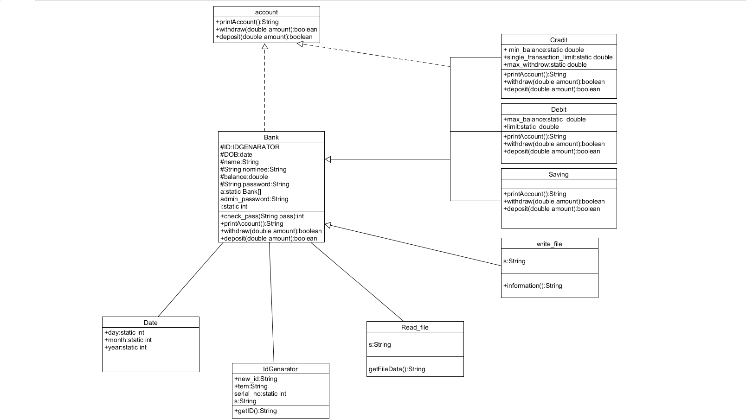

.

**Tools Used:**

To develop this project we have used the following:

* Scite
* Umlet

**OOP and Java Concepts Used:**

* Inheritance: Inheritance concept used in Saving, Debit and Credit classes.
* Polymorphism: This concept is used in Bank, Saving, Debit and Credit classes.
* Encapsulation: All of classes are included by this concept.

**Impact of this Project:**

**The** impact of the project is very essential for society and economy.

We are making the banking system to easy by which people are easily done their banking work.

People are benefitted by many thing ,these are given below

* People are not face the difficulties to create a account
* They are easily open account by 500 taka and get their bank id number instantly
* They are easily manage their bank account
* They can get help by the bank authority
* They will get credit account features and so on.

**Limitations and Possible Future Improvements:**

This project has been designed to meet all of the user requerments but it too has certain limitations. In this project has not connected with any mobile banking or ATM.Currently it only support single branch of bank.There are some lacks of data security.There are some limitation for deposite and withdraw money. Here no option for customer service at yet.

The “Banking Online System is a big and ambitious project. We work on it for more new features and more easiest way to browse. So the possible future improvements can be like customer issues development based on their needs, so the help desk will be aware of their needs and easy to use.More branches of the bank, maybe it will be international, that means more ATM machines outside. There will be more hard security system for accounts.